

**FPT ACADEMY INTERNATIONAL**

FPT – APTECH COMPUTER EDUCATION

|  |  |  |  |
| --- | --- | --- | --- |
| **Center Name:** | FPT – Aptech – HCM2 | | |
|  | Address:590 Cach Mang Thang Tam,  District 3, Ho Chi Minh City | | |
| **Instructor:** | Ms. Le Mong Thuy | | |
|  |  | | |
| **Class:** | T1.2208.A0 | | |
| **Group:** | 07 | | |
| **Group members** | **Name**  Nguyen Anh Duy | | **Student ID**  Student1408049 | |
|  | Le Tan Kha | | Student1408043 | |
|  | Le Thi Hoa Dang | | Student1405212 | |
|  |  | |  | |
| **Project Duration** | Start date | Nov 14th 2022 | | |
|  | End date | Dec 14th 2022 | | |

**This is to certify that**

Nguyen Anh Duy

Le Thi Hoa Dang

Le Tan Kha

**has successfully designed & developed**

eProject: RYAN Sports Club

**Submitted by:**

Nguyen Anh Duy

**Date of issue:** Nov 14th 2022

**Authorized Signature:**







**FPT-APTECH COMPUTER EDUCATION 1**

**ACKNOWLEDGMENT 3**

**SYNOSIS 3**

**PROBLEM DEFINITION 3**

**CUSTOMER’S REQUIREMENTS SPECIFICATION (CRS) 4**

**Business/project Objective 4**

**Hardware/software Requirements 5**

**SCOPE OF THE WORK (IN BRIEF) 6**

**Architecture and design of the system 7**

**Diagram of website 8**

**TASK SHEET REVIEW 1 9**

**SITE MAP 10**

**MOCK OF THE WEBSITE 11**

1. **Home 11**
2. **About Us 12**
3. **Activities 13**
4. **Gallery 14**
5. **Feedback 15**
6. **Membership**
7. **Sign In**

**TASK SHEET REVIEW 2 19**

**WEBSITE DESCRIPTION 20**

1. **Home 11**
2. **About Us 12**
3. **Activities 13**
4. **Gallery 14**
5. **Feedback 15**
6. **Membership**
7. **Sign In 26**

**JAVASCRIPT DESCRIPTION 27**

1. **Product data json and JavaScript 27**
2. **Filter JavaScript 30**
3. **Comparison JavaScript**
4. **Gallery 31**
5. **Feedback 34**
6. **Membership**
7. **Sign In, Sign Up, Forgot password 35**

**TASK SHEET REVIEW 3 36**



ACKNOWLEDGMENT

On behalf of all the members of group 7, I would like to thank you all for the hard works, support to make this eProject complete successfully. Especially Ms. Le Mong Thuy, our teacher, she helped us a lot from the day that we started to study at FPT Aptech. With this eProject, she has guided us with her enthusiasm and rigor. Because of her guidance, we would be able to finish this project. Besides, I want to thank all the team members of group 4, each of the team members has been working continuously in 4 weeks in order to complete this project. Last but not least, we would like to say thank you to our family for always supporting us, creating the best conditions for us to focus on the project, and putting faith in the dreams we pursue.

**SYNOSIS**

In this task, we are assigned to design and develop a business website which meets all the requirements from our client under the name RYAN Sports Club. The business is all about promoting sports and a healthy lifestyle for its customers. Client's goal for the website is to bring convenience to customers who can easily View our facilities and activities in detail.

**PROBLEM DEFINITION**

RYAN Sports Club, an effort has been made to provide world class facilities and infrastructure for the promotion of sports and health. During the past, RYAN sports club has emerged as one of the best facilities in the country in the area of sports and health and also it is making strides to acquire a formidable presence internationally. The club provides facilities like “Indoor Sports”, “Outdoor Sports” and “Recreation”. All this information is required to be presented in organized form for which a website is required to be created.

The website is to be developed for the Windows Platform using HTML5, JavaScript and Geolocation. The site should work well in all leading browsers including Chrome, IE, Firefox etc.



CUSTOMER'S REQUIREMENTS SPECIFICATIONS (CRS)

Client: RYAN Sports Club

Business/Project Objective:

In this task, we are assigned to design and develop a business website which meets all the requirements from our client under the name RYAN Sports Club. The business is all about promoting sports and a healthy lifestyle for its customers. Client's goal for the website is to bring convenience to customers who can easily View our facilities and activities in detail.

You are supposed to create a website for them with the below mentioned requirement specifications.

Input to the system:

* Membership sign-in, sign-up page
* Contact Page
* Feedback page

Output from the system:

* A homepage with a description about the club + navigational links
* Display facilities (indoor, outdoor, recreational)
* List of activities arranged yearly.
* Picture gallery
* Information about each sport
* Top sport persons.
* The location of the Club under the Contact Us page.

Process:

* Sign in; sign up (validate)

**Expected delivery date:** 14th-Nov-2022



List of deliverables:

* + Document Word.
  + Source code.

**Hardware/ Software Requirements:**

**For developer**

**Hardware**

Intel Pentium 4 processor or higher 1 Gigabytes of RAM or higher

**Software**

Windows 7 OS or higher Adobe Dreamweaver

Web browsers such as IE, Chrome or Firefox are supporting HTML5, CSS3 and JavaScript.

**For web users**

**Hardware**

Intel Pentium 4 processor or higher 1 Gigabytes of RAM or higher

**Software**

Windows 7 OS or higher

Web browsers such as IE, Chrome or Firefox are supporting HTML5, CSS3 and JavaScript.



SCOPE OF THE WORK (IN BRIEF)

After a long and detailed discussion, our group has decided to create a website contain the following webpages:

**Home**: We divided the section into 3 parts:

* 1. *Part 1 header: main links, “Visit us to know more”*
  2. *Part 2 body: activities, facilities, benefits section to provide info of the club to the customer*

- *Part 3 footer: small contact us part at the bottom, copyright*

**About Us :** Display social activities and development cooperation

**Activities**: Displays the activities from Indoor, Outdoor, to Recreational Sports.

* Fitness(indoor)
* Dance(indoor)
* Kick-Boxing(indoor)
* Basketball(outdoor)
* Soccer(outdoor)
* Volleyball(outdoor)
* Sauna(indoor)
* Mediation(indoor)

**Picture Gallery:** club's picture

Feedback: customer reviews and comments

**Membership**: Displays Promotions coupon to use

**Sign In:** Display form Sign In, Sign up



Architecture and design of the system



**Diagram of the website**

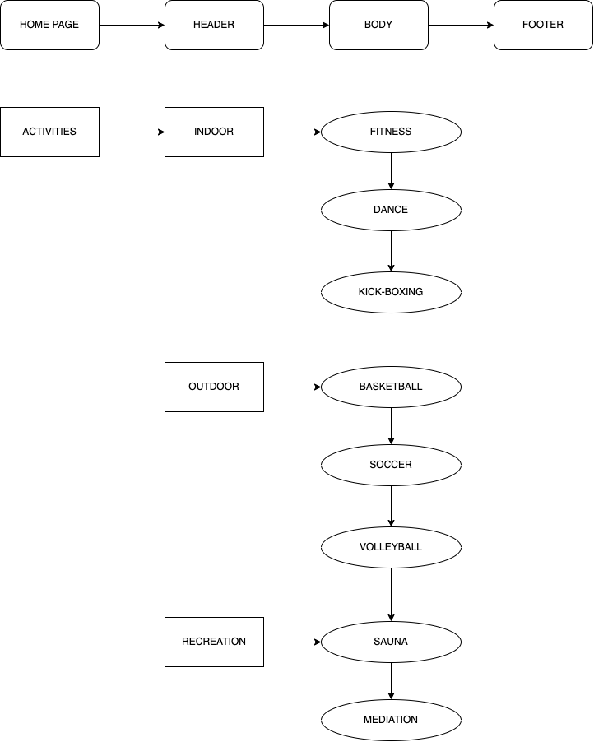

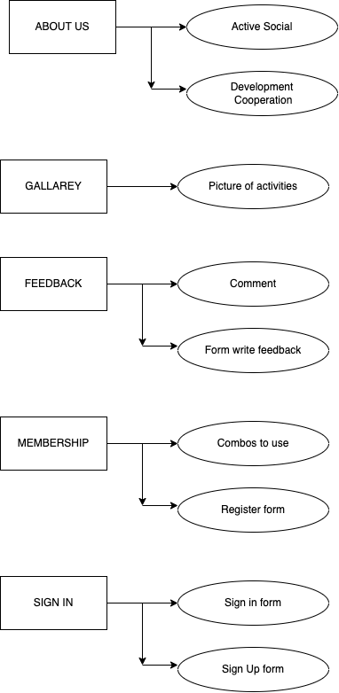



TASK SHEET REVIEW 1

|  |  |  |  |  |  |  |  |
| --- | --- | --- | --- | --- | --- | --- | --- |
| **Project Ref. No.:**  **eP/Advertisement Portal Management**  **System/01** | | **Project Title:** | **Activity Plan Prepared By:** | **Date of Preparation of Activity Plan:** | | | |
| **Sr.**  **No.** | **Task** | **Actual Start**  **Date** | **Actual Days** | **Teammate Names** | **Status** |
| 1 | Problem Statement | RYAN SPORTS CLUB | Nguyen Anh Duy | 14-Nov-22 | 1 | Nguyen Anh Duy | Completed |
| 2 | Analysis of RYAN Sports Club requirements about  the website | 14-Nov-22 | 1 | Nguyen Anh Duy | Completed |
| 3 | The scope of the work (in  brief) | 14-Nov-22 | 1 | Le Thi Hoa Dang | Completed |
| 4 | Architecture and design  of the system | 14-Nov-22 | 1 | Le Thi Hoa Dang | Completed |
| 5 | Diagram of the website | 14-Nov-22 | 1 | Le Thi Hoa Dang | Completed |
| 6 | Task Sheet | 14-Nov-22 | 1 | Le Tan Kha | Completed |

|  |  |
| --- | --- |
| **Date: 14th Nov 2022** | |
| Signature of Instructor:  **Ms. Le Mong Thuy** | Signature of Team Leader:  **Nguyen Anh Duy** |

**MOCK OF THE WEBSITE**

**Home**

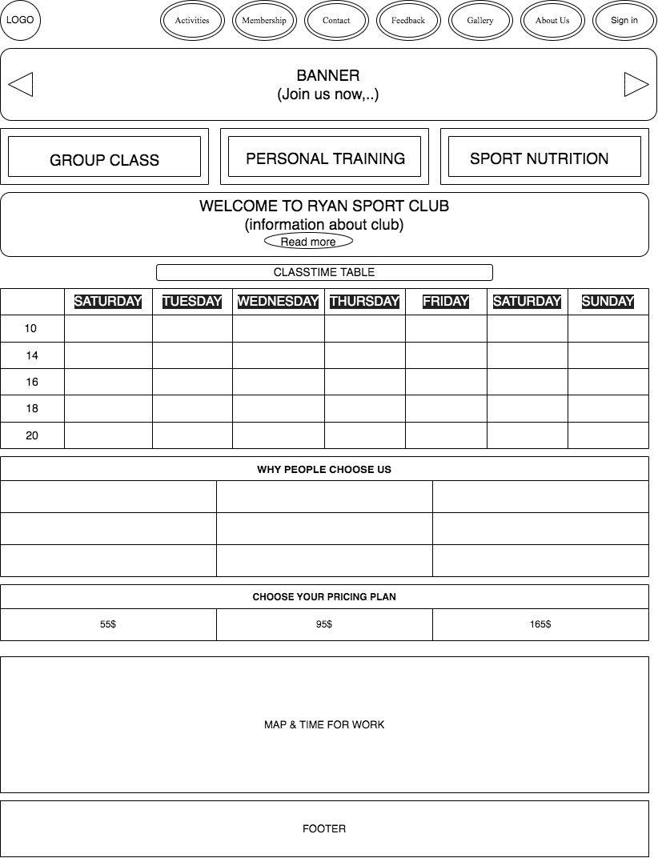

**About Us**

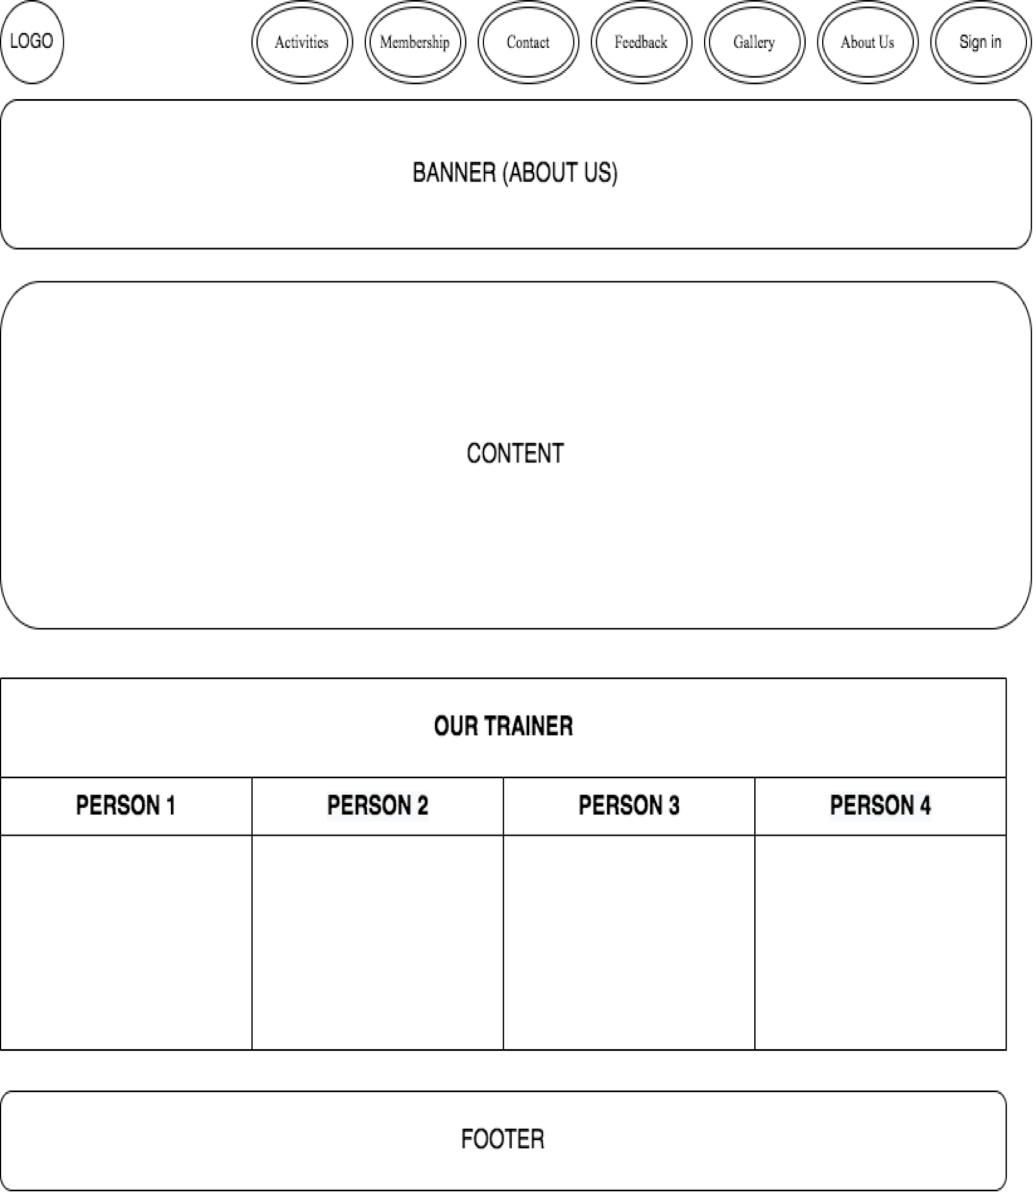

**Activities**

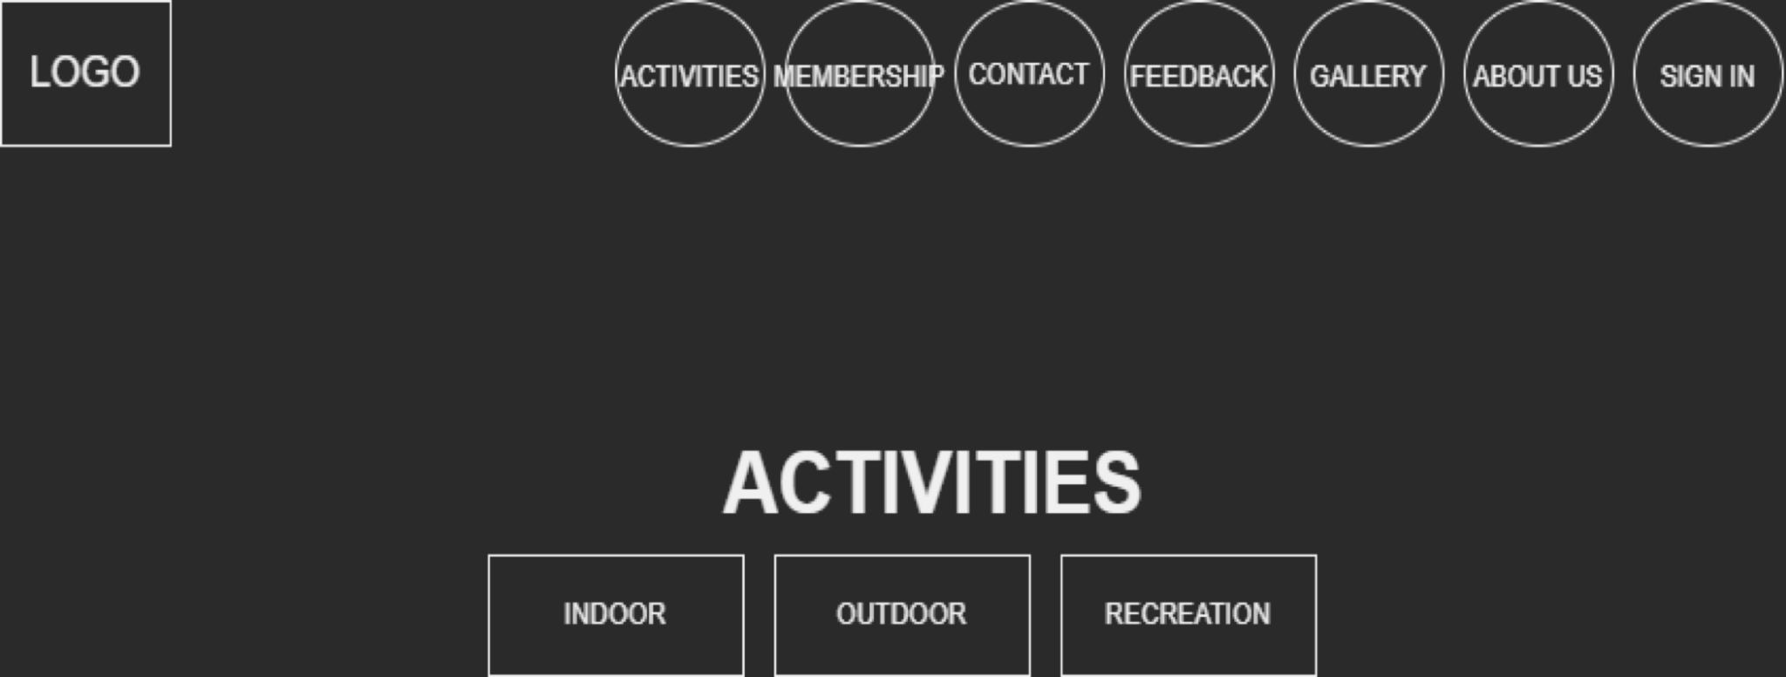

**Gallery**

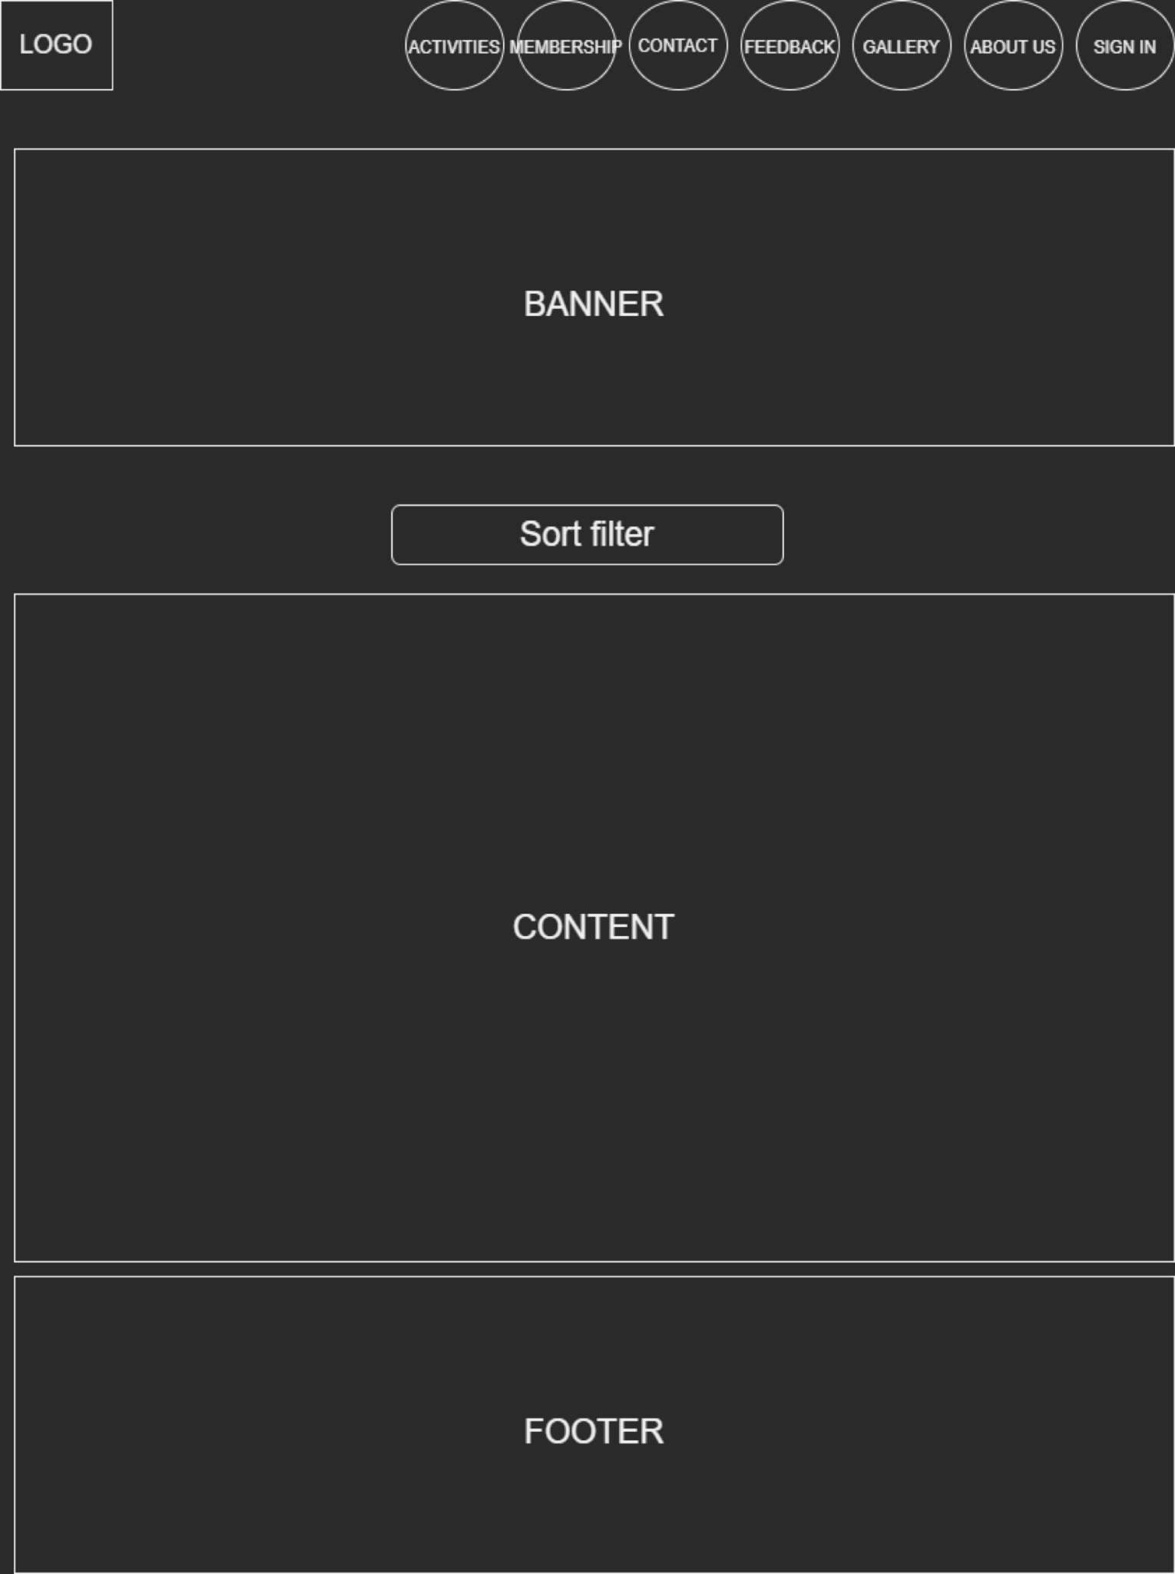

**Feedback**

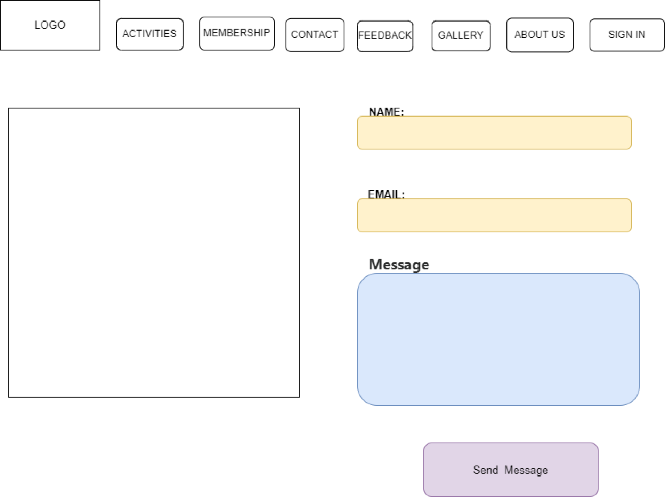

**Membership**

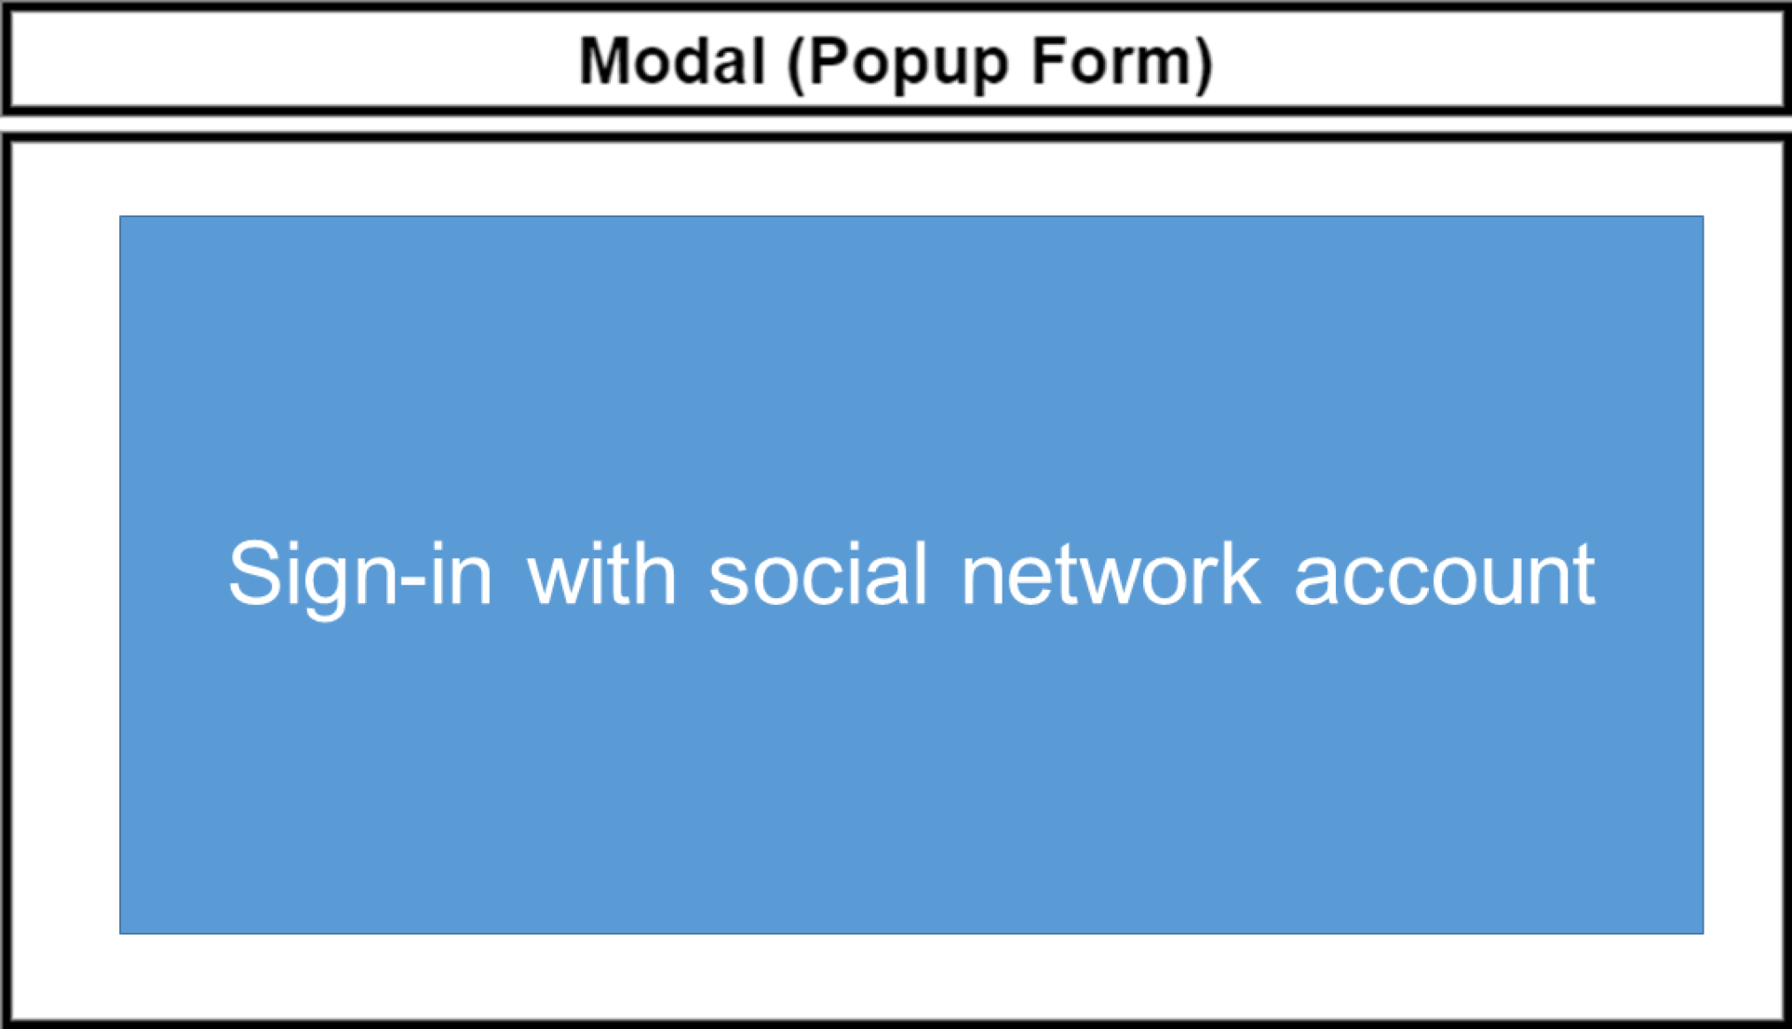

**Sign In**

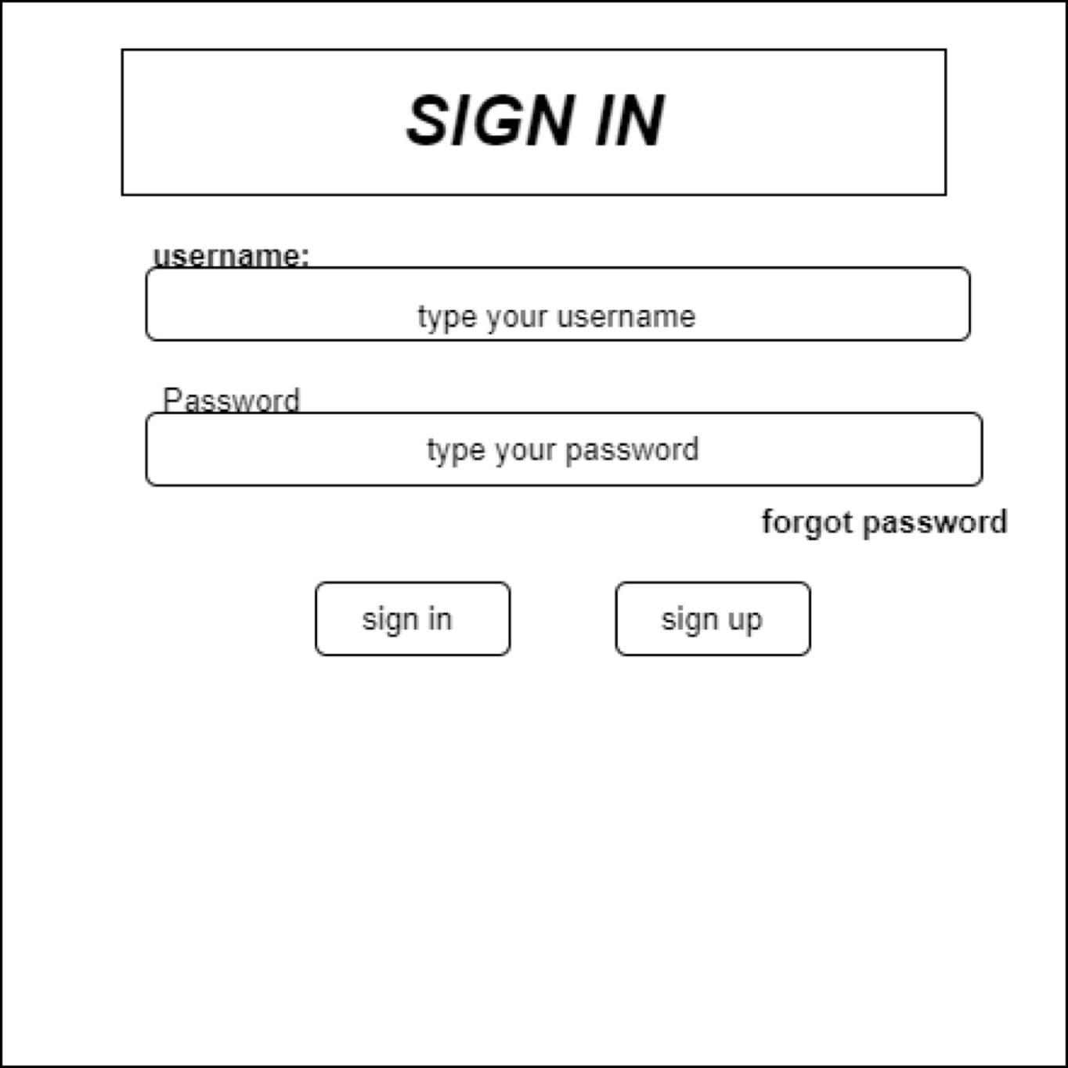

TASK SHEET REVIEW 2

|  |  |  |  |  |  |  |  |
| --- | --- | --- | --- | --- | --- | --- | --- |
| **Project Ref. No.: eP/Advertisement**  **Portal Management**  **System/01** | | **Project Title:** | **Activity Plan Prepared By:** | **Date of Preparation of Activity Plan:** | | | |
| **Sr.**  **No.** | **Task** | **Actual Start Date** | **Actual Days** | **Teammate Names** | **Status** |
| 1 | Site map | RYAN  Sports Club | Nguyen  Anh Duy | 14th-Nov-2022 | 1 | Nguyen Anh Duy | Completed |
| 2 | Mock of the website | 14th-Nov-2022 | 2 | Le Thi Hoa Dang | Completed |
| 3 | Task sheet | 14th-Nov-2022 | 2 | Le Thi Hoa Dang | Completed |

|  |  |
| --- | --- |
| **Date: 14th Nov 2022** | |
| Signature of Instructor:  **Ms. Le Mong Thuy** | Signature of Team Leader:  **Nguyen Anh Duy** |

WEBSITE DESCRIPTION

* 1. **Home page**
     1. Description

Home page displays following information

* + - * **Home 11**
      * **About Us 12**
      * **Activities 13**
      * **Gallery 14**
      * **Feedback 15**
      * **Membership**
      * **Sign In**
    1. Screenshot

Homepage

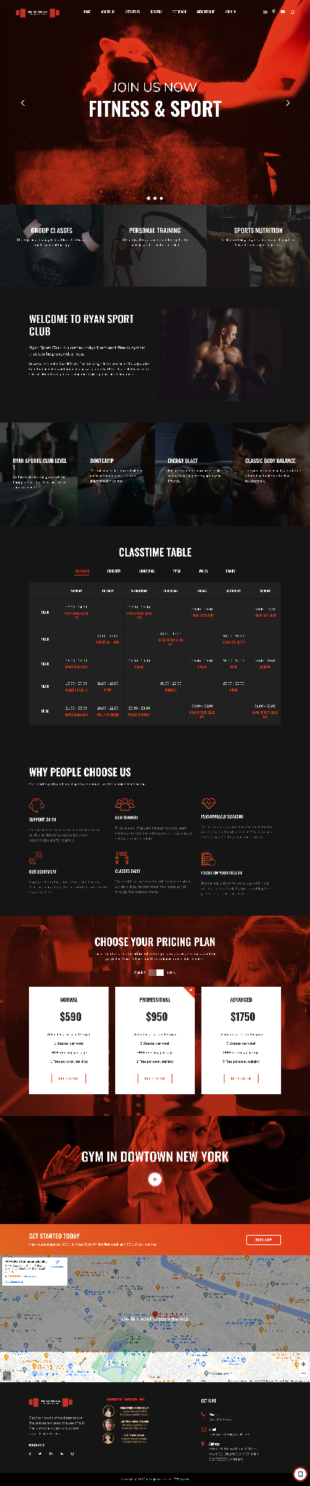

**About Us**

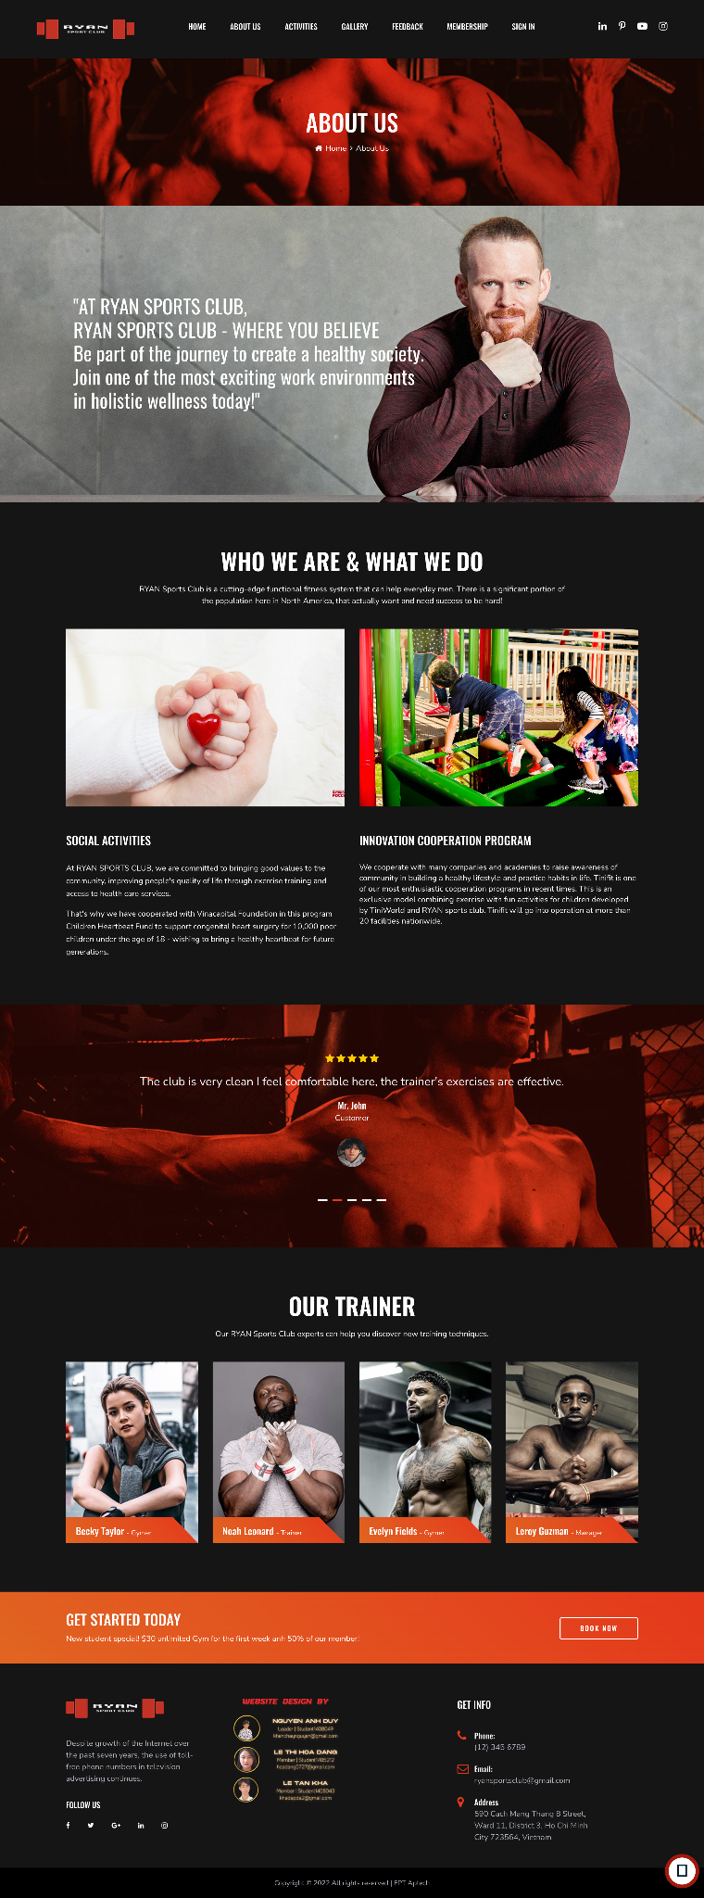

**Activities**

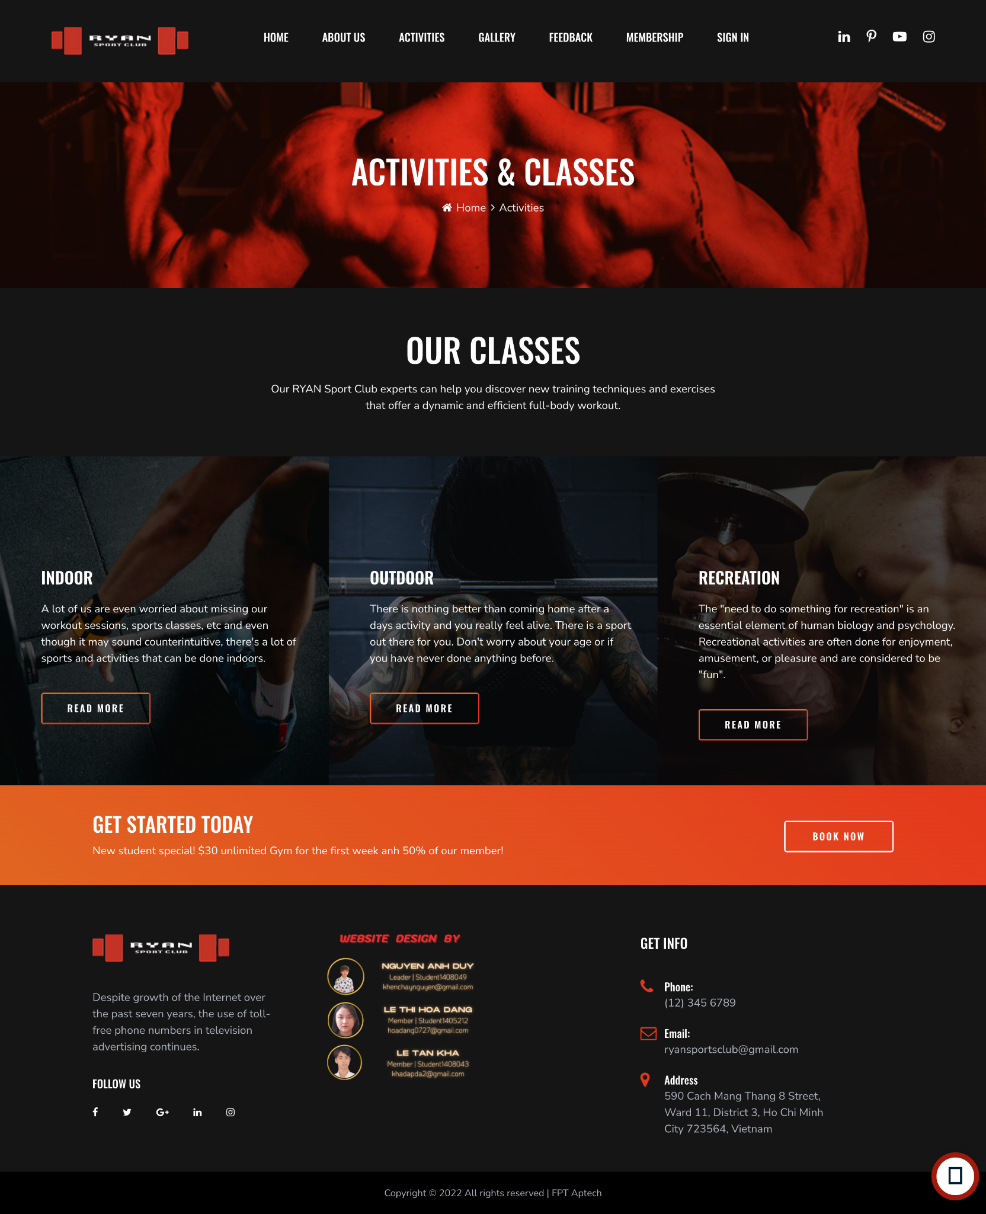

Gallery

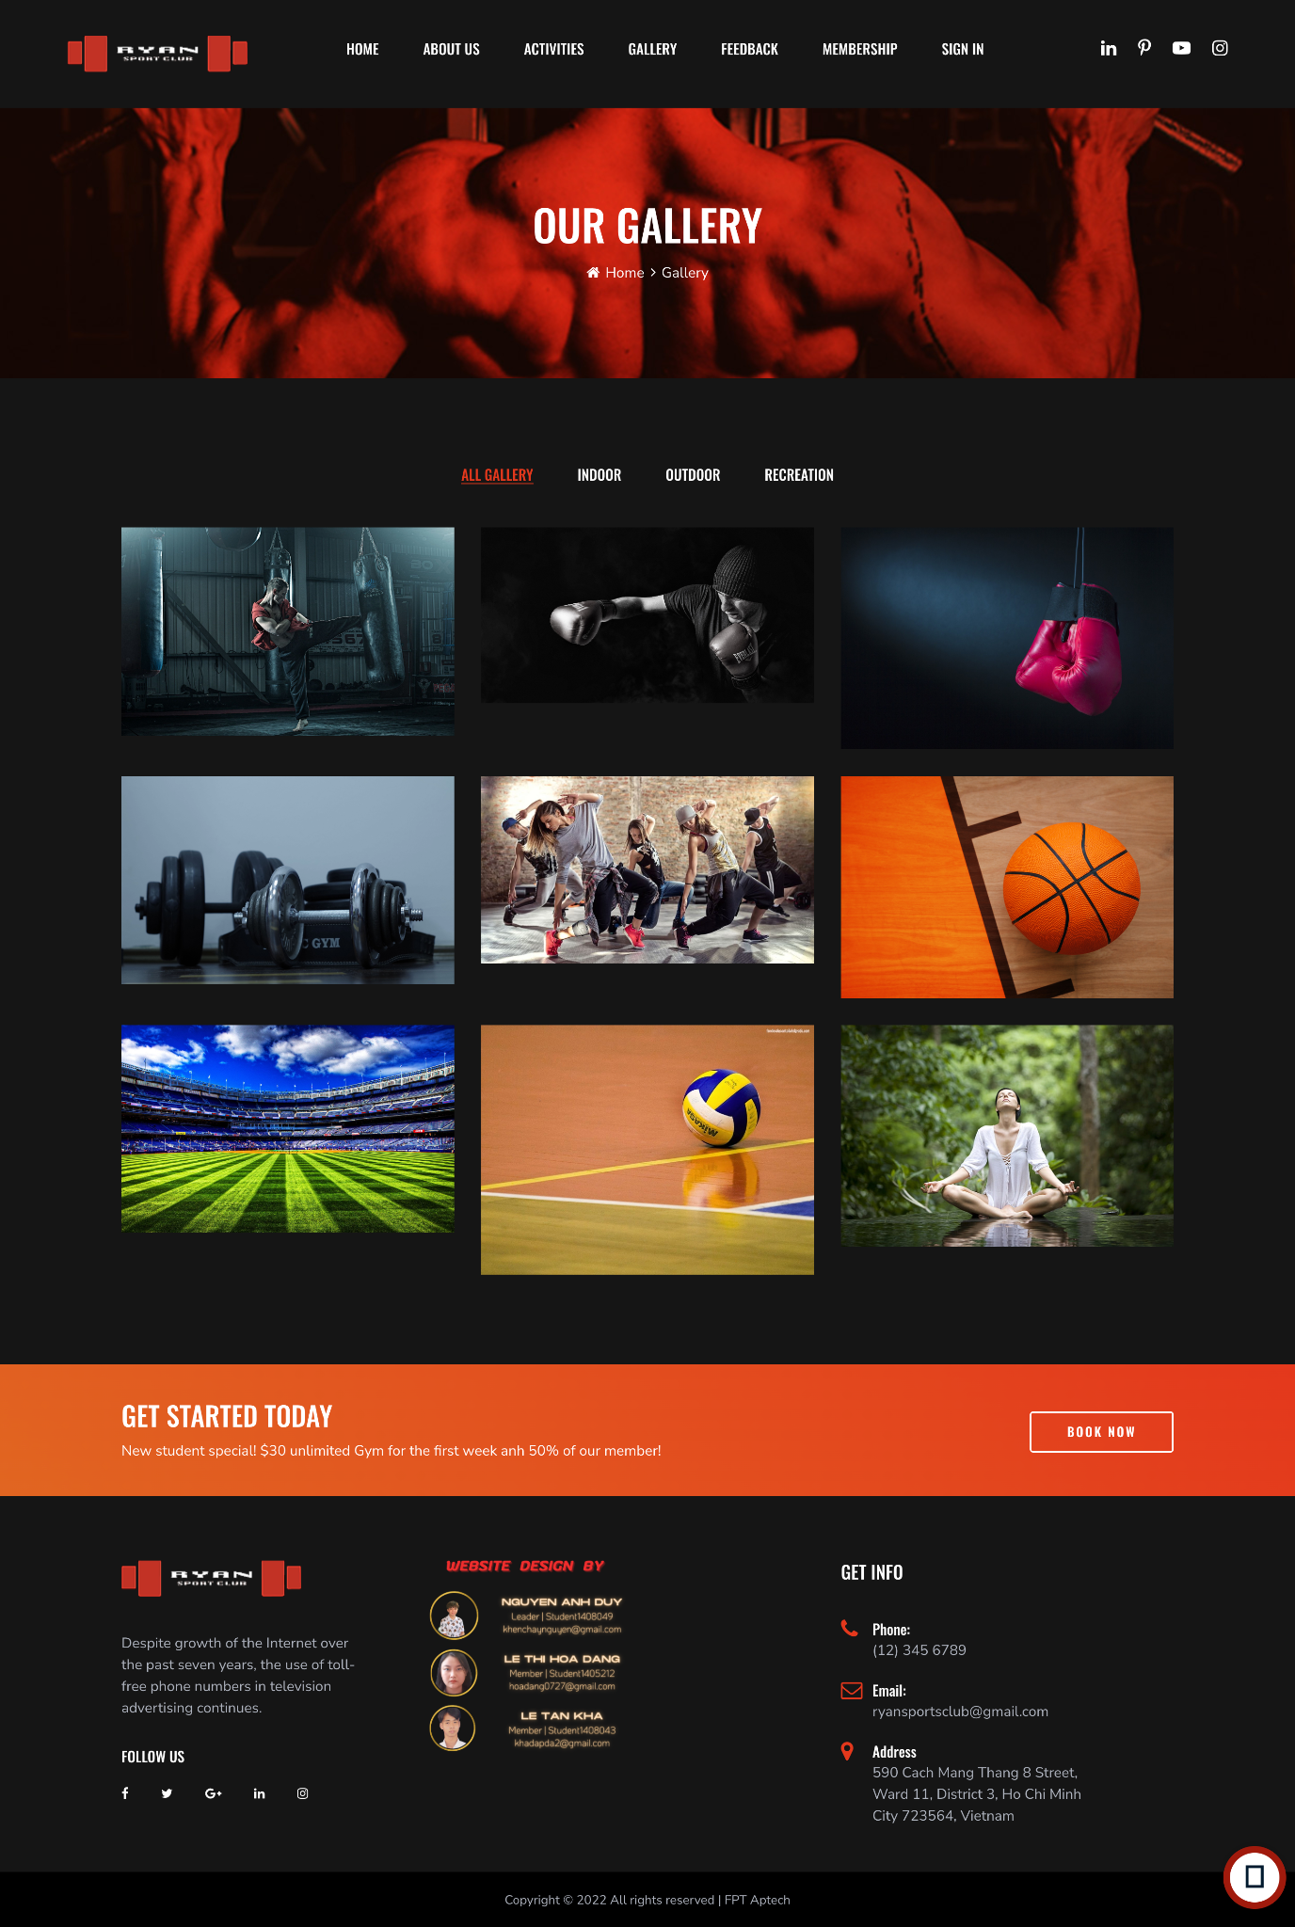

Feedback

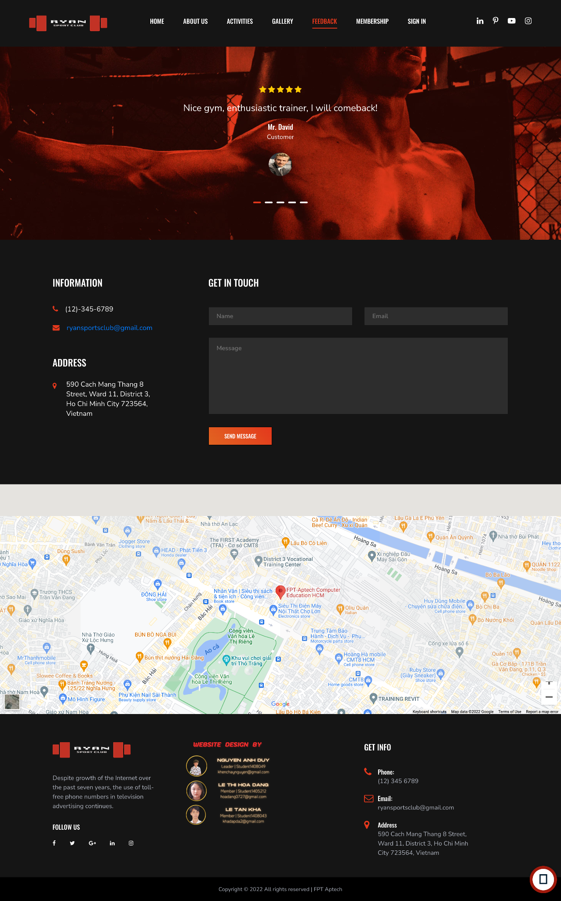

Membership

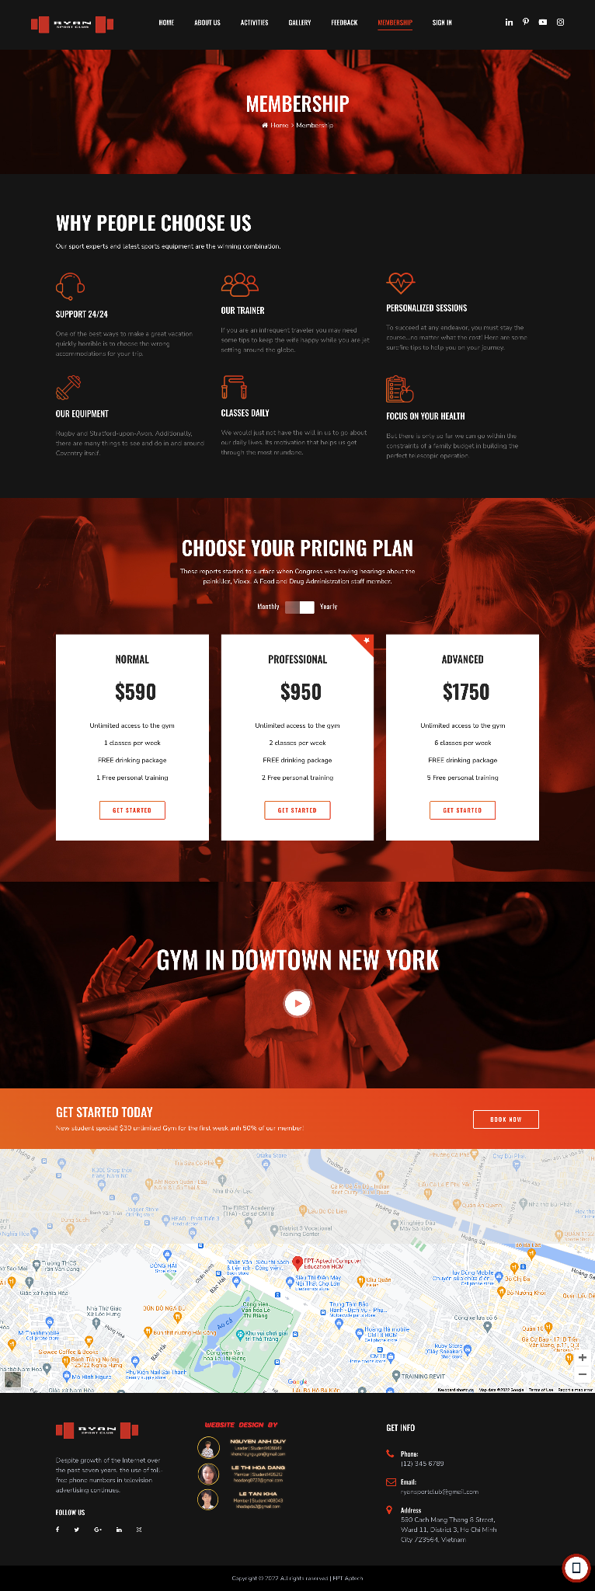

**Sign In**

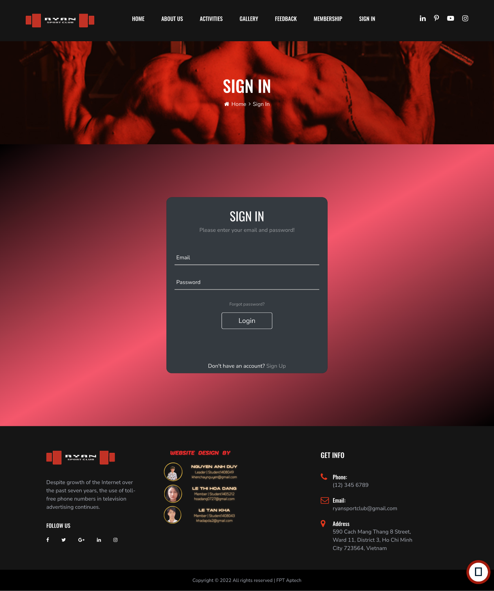

**Logo**

This logos designed by Le Thi Hoa Dang - Student1405212  


JAVASCRIPT DESCRIPTION

1. **Pricing plan Javascript.**
2. **Description**

**This script used to change price from Monthly to Yearly.**

1. 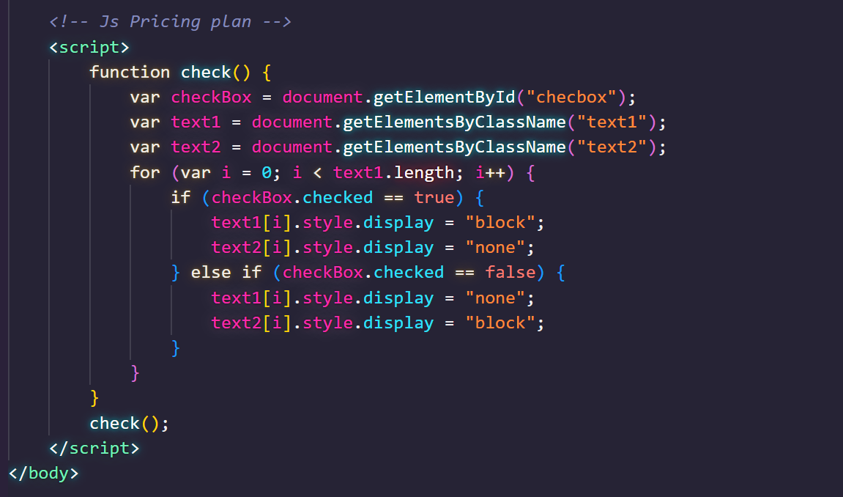**Screenshot**
2. **Scroll back to top JavaScript**
   1. Description

This script is used to scroll back to the top of the page.

* 1. Screenshot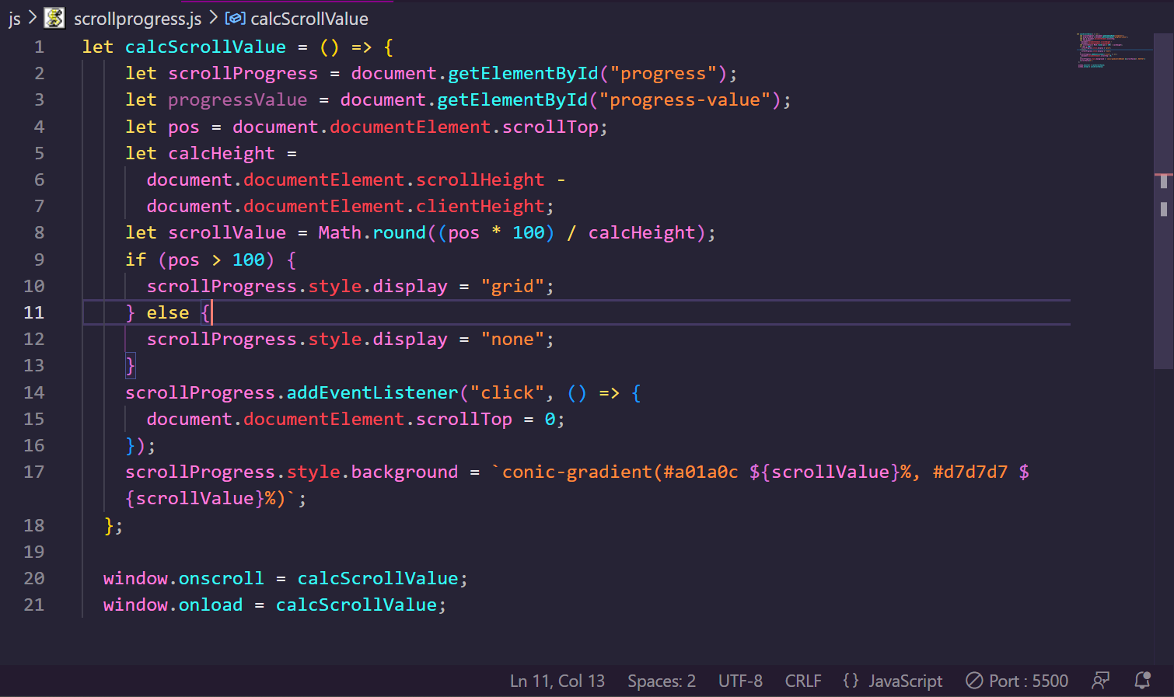

1. **Timetable JavaScript**
   1. Description

This script used for comparing items in the sport club page.

* 1. Screenshot

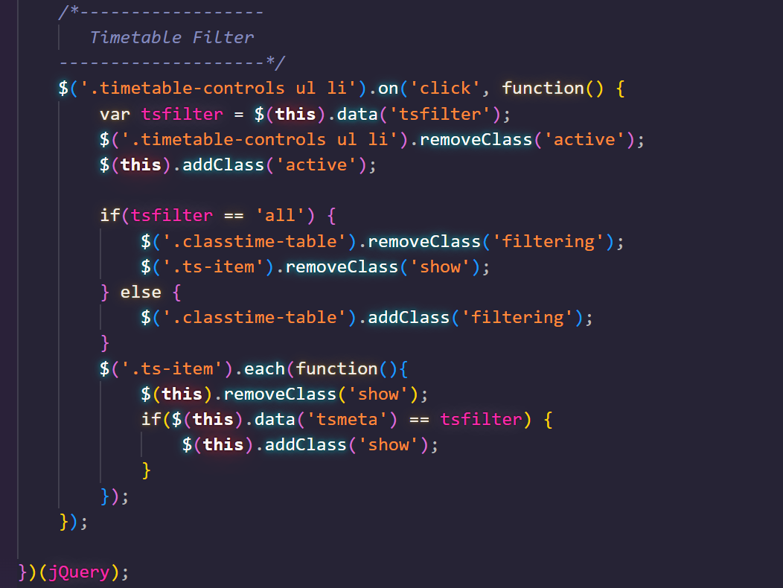

1. **Contact us JavaScript**
   1. Description

This script is used for contacting our customer service.

* 1. Screenshot

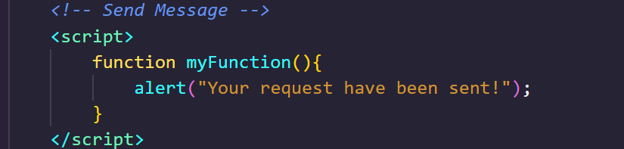

1. Gallery
2. Description

This script is used for filter images by classes in Gallery page. It is implemented with the support of the Jquery library.

1. Screenshot

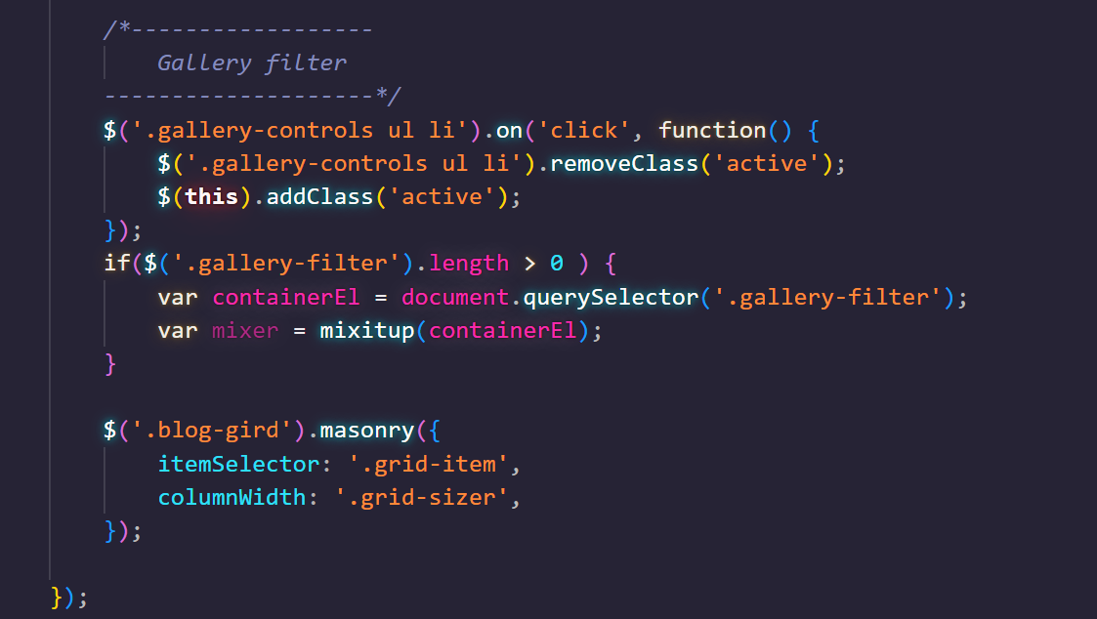

TASK SHEET REVIEW 3

|  |  |  |  |  |  |  |  |
| --- | --- | --- | --- | --- | --- | --- | --- |
| **Project Ref. No.: eP/Advertisement**  **Portal Management**  **System/01** | | **Project Title:** | **Activity Plan Prepared By:** | **Date of Preparation of Activity Plan:** | | | |
| **Sr.**  **No.** | **Task** | **Actual Start Date** | **Actual Days** | **Teammate Names** | **Status** |
| 1 | Website layout | RYAN Sports Club | Nguyen Anh Duy | 14th-Nov-2022 | 5 | Le Thi Hoa Dang | Completed |
| 2 | Edit CSS | 14th-Nov-2022 | 5 | Le Thi Hoa Dang | Completed |
| 3 | Modal JavaScript | 14th-Nov-2022 | 5 | Nguyen Anh Duy | Completed |
| 4 | Filter & comparison JavaScript | 14th-Nov-2022 | 5 | Nguyen Anh Duy | Completed |
| 5 | Product detail and data  JSON | 14th-Nov-2022 | 3 | Nguyen Anh Duy | Completed |
| 6 | Task sheet review | 14h-Nov-2022 | 3 | Le Tan Kha | Completed |

|  |  |
| --- | --- |
| **Date: 14th Nov 2022** | |
| Signature of Instructor:  **Ms. Le Mong Thuy** | Signature of Team Leader:  **Nguyen Anh Duy** |